Name :R.Mouni Course:Generative AI

Reg no:192472283 Code:CSA6502

Question 1: Tokenization

Tokenization of the Word "UNHAPPINESS"

Introduction
Tokenization is one of the first and most important steps in Natural Language Processing (NLP). It is the process of dividing text into smaller units called tokens. These tokens may be words, sub-words, characters, or sentences.
Modern AI models such as BERT, GPT, RoBERTa, and T5 generally use sub-word tokenization instead of whole-word tokenization because it helps them understand rare, new, and complex words efficiently.
For example, instead of storing the entire word "UNHAPPINESS" as one token, the tokenizer breaks it into meaningful smaller parts.

(a) Split "UNHAPPINESS" into 3 Reasonable Sub-word Pieces

Answer
UN + HAPPI + NESS

Explanation of Each Sub-word
Sub-word | Meaning | Purpose
UN | Prefix meaning "not" or "opposite" | Changes the meaning to negative
HAPPI | Root word derived from "Happy" | Represents the main meaning
NESS | Suffix meaning "state or quality" | Converts an adjective into a noun

Formation of the Word
UNHAPPINESS
│
┌─────────┼─────────┐
│ │ │
UN HAPPI NESS
(Prefix) (Root) (Suffix)

Step-by-Step Meaning
Happy
│
Add Prefix "UN"
│
Unhappy
│
Add Suffix "NESS"
│
Unhappiness

Why This Split is Reasonable
The tokenizer separates the word into meaningful language components:
- UN is a commonly used prefix.
- HAPPI represents the root concept "happy."
- NESS is a common suffix found in many English words.
Examples:
- Happiness
- Kindness
- Darkness
- Sadness
- Weakness
Because these pieces occur frequently during training, the model already understands them.

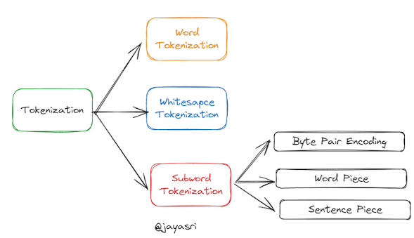

Visual Representation
UNHAPPINESS

│
▼

┌──────┬────────┬────────┐
│ UN │ HAPPI │ NESS │
└──────┴────────┴────────┘

Prefix Root Suffix

Another Possible Split
There is no single correct answer.
Other reasonable splits include:
UN + HAPPY + NESS

or

UNHAPPY + NESS
Different tokenizers (BPE, WordPiece, SentencePiece) may produce different token sequences depending on their vocabulary.

Benefits of this Split
✔ Smaller vocabulary
✔ Better understanding of unknown words
✔ Less memory usage
✔ Better generalization
✔ Works across different languages

(b) Why Does Sub-word Tokenization Help?

Sub-word tokenization allows the model to understand rare or unseen words by breaking them into smaller meaningful parts that it has already learned during training. Even if the complete word "UNHAPPINESS" has never appeared before, the model recognizes UN, HAPPI, and NESS, enabling it to infer the word's meaning.

Detailed Explanation
Suppose the model has never seen the word
UNHAPPINESS
during training.

Whole-word Tokenization
UNHAPPINESS

↓

Unknown Token (UNK)
The model loses all information because the word is treated as unknown.

Sub-word Tokenization
UNHAPPINESS

↓

UN + HAPPI + NESS
Now the model already knows:
- UN → Negative prefix
- HAPPI → Happy
- NESS → State or quality
So it can estimate the meaning as:
"The state of not being happy."

Comparison
Whole-word Tokenization | Sub-word Tokenization
Large vocabulary required | Small vocabulary required
Unknown words become UNK | Rare words are split into known pieces
Poor handling of new words | Excellent handling of unseen words
More memory usage | Less memory usage
Lower flexibility | Higher flexibility

Advantages of Sub-word Tokenization
- Handles unknown words effectively.
- Reduces vocabulary size.
- Improves model accuracy.
- Supports multiple languages.
- Learns prefixes, roots, and suffixes.
- Helps understand spelling variations.
- Efficiently processes compound words.
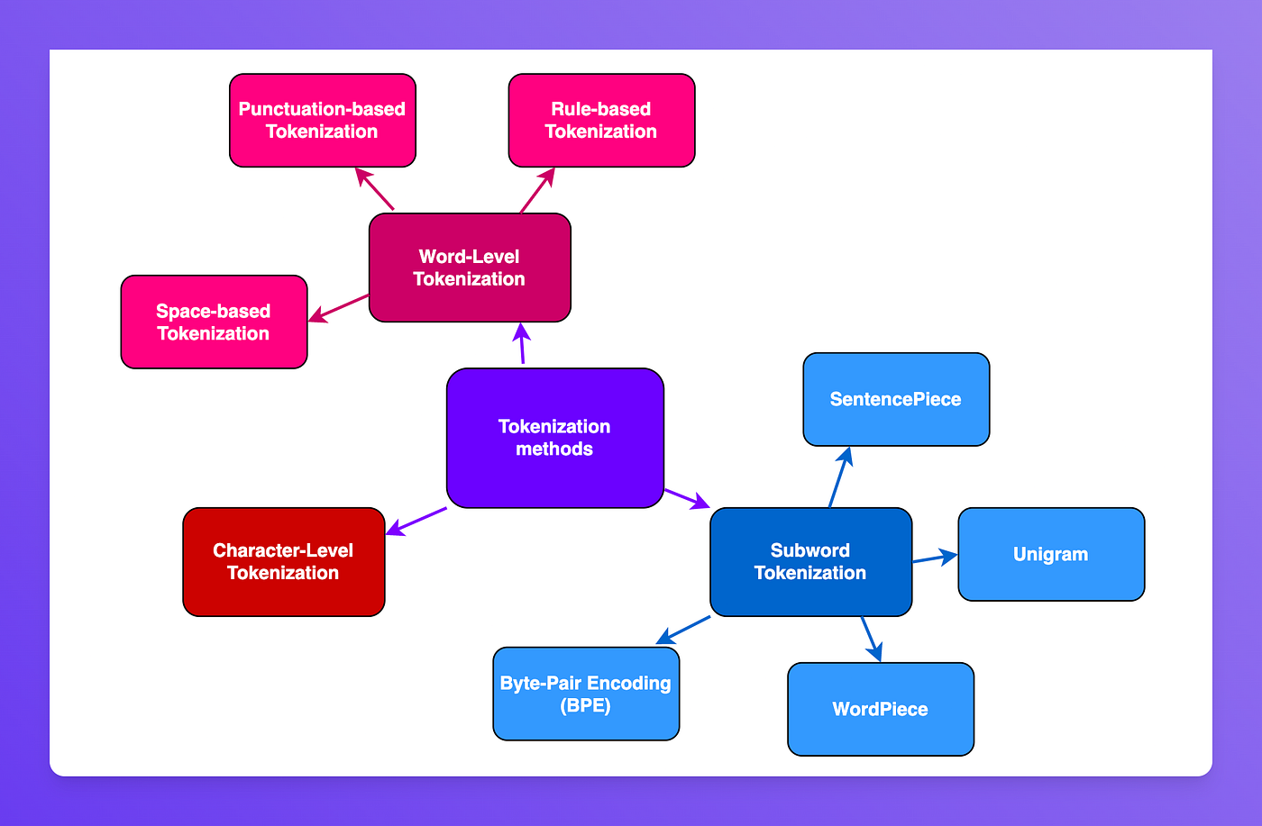

Real-Life Examples
Word | Sub-word Tokens
Unhappiness | UN + HAPPI + NESS
Impossible | IM + POSSIBLE
Restarted | RE + START + ED
Friendship | FRIEND + SHIP
Carefully | CARE + FULLY

Conclusion
Sub-word tokenization is a powerful NLP technique that breaks complex or rare words into meaningful components. This approach reduces vocabulary size, improves the handling of unseen words, and enables modern language models such as GPT and BERT to better understand and generate natural language. It is one of the key reasons why these models perform well even when encountering words they were not explicitly trained on.

